**Liver first approach in patients with synchronous colorectal cancer metastases: systematic review and meta-analysis**

Bruno Mirandola Bulisani (1), Milena Arruda de Oliveira Leite (1), Jaques Waisberg (1).

1. Centro Universitário FMABC - Faculdade de Medicina do ABC, Brazil

**ABSTRACT**

**Objective:** The most appropriate approach for patients with colorectal carcinoma and synchronous liver metastases remains controversial. The objective of this study is to analyze the results of the liver first approach in patients with colorectal cancer with synchronous hepatic metastases initially submitted to systemic chemotherapy, and/or resection of metastatic lesions and resection of primary colorectal carcinoma. **Methods:** Available systematic review articles were selected based on PRISMA guidelines. Electronic searches of related publications have been carried out on the MEDLINE, EMBASE, LILACS and Cochrane Central Register of Controlled Trials databases. Studies showing the method of the procedure were included, the subsequent outcomes and that provided information related to the survival of patients to the liver first approach in patients with synchronous liver metastases of colorectal cancer. Proportional meta-analysis with random-effects Restricted Maximum Likelihood method was used to summarize the overall survival 3- and 5-years and recurrence rate. **Results:** 855 publications on liver first approach results were identified. Then, three independent reviewers screened the titles of the articles and their abstracts, of which 750 articles were excluded. We found 29 retrospective and comparative studies that met the screening criteria and were identified and examined. No randomized controlled trials were identified during the investigation period. **Conclusions:** To offer a potentially curative opportunity for patients with synchronous hepatic metastases considered unresectable initial, neoadjuvant treatment with systemic chemotherapy for hepatic metastasis can lead the patient to the condition of resectability of liver metastases. Thus, the decision regarding the resection of primary colorectal carcinoma and liver metastases is conditioned to the individualized response of the synchronous liver metastases of each patient to systemic chemotherapy as a liver first approach.

**Keywords:** Colorectal neoplasms, metastatic neoplasia, liver neoplasm, liver surgery, hepatectomy

**INTRODUCTION**

Colorectal cancer (CRC) is the 3rd most common cancer in the world (1) and the 4th with the highest mortality rate (2). Liver metastases of colorectal cancer (CLM) are considered synchronous when previously diagnosed, at the same time or up to 6 months after the evidence of the primary site (3.4) and reach up to 25% (4.5) of cases of CRC. This presentation of the disease is strongly associated with low survival relative to patients with metastatic liver disease (3,4). Patients with synchronous CLM are people with more aggressive cancer biology and who have a lower probability of long-term survival (6) since most are carriers of unresectable disease (7).

In addition to systemic chemotherapy, the most appropriate approach for patients with synchronous CRC and CLM is still controversial (7). Complete resection of neoplasms offers a higher 5-year survival rate of up to 58% (7.8), however, only 25% of patients with synchronous CLM are candidates for radical oncological resection (7-10).

The conventional approach for patients with resected synchronous CLM is made in two stages that comprise the resection of the CRC, followed by chemotherapy and resection of the CLM in a second moment (11). The biggest disadvantage of this approach is the opportunity of progression of CLM to the condition of unresectability in the attempt to control the CRC, especially in the context of the postponement of systemic treatment due to morbidity associated with colorectal resection and/or adjuvant chemotherapy (12,13), thus preventing systemic chemotherapy focused on CLM and its resection.

Simultaneous resection of CRC and CLM has been increasingly performed in selected patients with preoperative morbimortality and acceptable survival outcomes (14,15). However, this method is related to the increase in post-operative complications when a broader hepatic CLM resection is performed (16,17). Although this procedure may be advantageous in terms of shorter time and lower hospital admission costs, it is not feasible in patients with high CLM burdens who require a large liver resection, or for elderly patients with locally advanced rectal cancer (18-20).

In patients with synchronous CLM, the best sequence for hepatic CLM resection time and systemic chemotherapy has not yet been defined and remains contentious (3,4,7,10,12,21-23). The hypothesis that hepatic metastasis is the most responsible for death was proposed by Mentha et al. (24) who described the liver first approach (LFA) as a regimen with systemic chemotherapy focused on liver metastases to obtain downstaging, followed by liver resection of the CLM, and subsequent resection of the primary CRC. Initially, this approach was indicated for patients with synchronous CLM of rectal cancer who required adjuvant chemoradiotherapy. The reason for the choice of LFA is that it allows the control of CLM, optimizing the chance of a potentially curative liver resection, which can provide greater survival of these patients (25,26).

For the treatment of these patients to be performed in a correct manner and chronology, proper selection of patients is essential to ensure the best perioperative and long-term oncological results. Essential components for determining whether the patient is a candidate for liver resection involve factors related to the disease, the patient (oncological criteria) and the anatomy of the lesions (technical/surgical criteria) (27).

LFA treatment for downstaging includes systemic chemotherapy and/or chemoradiotherapy followed by resection of the CLM before resection of the CRC (30,33,36,38). The primary objective of this approach is to control the synchronous hepatic metastases of the CRC and, thus, to improve the chances of a potentially curative liver resection and to obtain long survival (32,34,35).

Metastatic disease seems to be the most important factor in patient survival and the treatment of CLM should be a priority (30,33,34,36). Therefore, patients with unresectable CLM who respond to chemotherapy should be periodically reevaluated for resectability. In addition, relatively minor changes in the size of the CLM, especially at critical sites, may have significant implications for the technical viability of the section (37-39).

LFA may be an option for patients with early stage CRC and disseminated metastatic liver disease, or for patients with locally advanced CRC with limited or extensive liver disease (37,40,42). Patient selection is crucial to ensure the best possible survival results when using this method. Patients' choice for surgery is determined by response to neoadjuvant therapy and burden of liver disease (36). Thus, to offer a potentially curative opportunity for patients with unresectable CLM, there is a clear need for effective neoadjuvant treatment that provides high tumor response rates, leading to secondary resectability (37,41).

This systematic review with meta-analysis was developed to evaluate the effects of LFA in patients with synchronous CLM initially considered unresectable.

**METHODS**

*Literature research strategy*

A systematic literature review was carried out following recommendations from PRISMA (29). This systematic review was incorporated into the public PROSPERO systematic review protocol database (CRD42022337047). This article does not need the release of the ethics committee because it is research that involves data present freely available in the public domain (MEDLINE, EMBASE, LILACS and Cochrane Central Register of Controlled Trials) available or accessible without contact with the individual/s.

An electronic search was carried out for related publications, using the MEDLINE database (1966 to 2022), the Cochrane Central database, the EMBASE database and LILACS database, using the MESH database (Medical Subject Headings). The search descriptors were colorectal cancer or colorectal Neoplasm; Liver metastasis or hepatic metastasis; Colorectal Liver metastasis Surgery; synchronous colorectal Liver metastasis; hepatectomy or Liver resection or hepatic resection; rectal cancer; Liver first; Reverse Strategy or Reverse approach. Boolean operators were used to locate keyword variations in the search to ensure those keyword variations were captured.

Study titles were assessed, while those selected were reviewed by the respective abstracts. A list of references for selected articles was searched to identify related articles.

*Study selection*

Articles that showed results after LFA in patients with synchronous CLM were included. The references of all articles considered adequate were then reviewed in order to recognize articles that could have been ignored during the initial search, following the pre-established criteria for selection of studies. The minimum prerequisite for inclusion of information was studies containing patients with synchronous CLM and submitted to LFA.

The study was evaluated by two reviewers (BMB and JW) who individually reviewed each article using pre-defined criteria. After the initial search, journals, case reports, editorials, duplicate studies, conference summaries, non-human studies and studies that were not in English, Portuguese, Spanish, Japanese, German, French and Italian were excluded. Studies describing the use of systemic chemotherapy, followed by liver rescue surgery in patients with initially unresectable CLM were included for examination. Studies proposing a hybrid method linking liver resection ablation techniques, two-stage hepatectomy or resection of extrahepatic metastases with the aim of increasing the criteria for resection of CLM were also included for analysis, as long as the intention of the treatment was curative. Abstracts of studies of relevant interest were retrieved and subsequently reviewed for their importance. The full text of the selected articles was methodically reviewed. Those articles that defined the use of LFA with curative intention in patients with synchronous CRC and CLM were selected for study. Only articles on survival outcomes (global, short or long-term) of LFA were included. Studies detailing liver arterial perfusion as a method of chemotherapy or radiopharmaceutical delivery were excluded. Where multiple items were from the same or overlapping patient series, only the most complete or most recent study was included. The inconsistencies were mutually determined. The results were extracted and grouped as single arm studies, without a comparison arm, in the absence of these.

*Data extraction and critical evaluation*

The two reviewers used as a predefined protocol for data extraction. The data obtained included: title and reference information (first author, journal, year); clinicopathological characteristics; plasma level of carcinoembryonic antigen (CEA); primary lesion site; location, number and size of CLM; Response to neoadjuvant systemic chemotherapy before resection of CLM; average number of systemic chemotherapy cycles; large hepatectomies; percentage of R0 resection performed; percentage of patients who completed the LFA protocol; morbidity and mortality; follow-up; recurrence; disease-free survival; overall survival; 1, 3 and 5-year survival.

A large hepatectomy was defined as a resection of 3 or more Couinaud segments. A complete response was defined as the total disappearance of all hepatic lesions; a partial response was defined as a decrease of 50% or more of the sum of the largest diameters of hepatic target lesions. Progressive disease was considered to be the 25% or greater increase in the sum of the largest diameters of target lesions in the liver. If the partial response or progressive disease criteria were not met, the disease was considered stable.

The two reviewers recorded the relevant information contained in the selected papers separately to minimize selection bias. Duplicate articles were removed, and all discrepancies were clarified. The disagreements were resolved by the most senior reviewer.

*Inclusion & Exclusion Criteria*

The inclusion criteria adopted were: (a) series with patients with synchronous CLM; (b) data on surgical events and outcomes; c) the longest follow-up or the largest sampling, when two or more studies were published by the same institution. The reasons for excluding the articles were: (i) lack of information that the MHCC was synchronous; and (ii) most of the results were not adequately reported.

*Outcomes of interest*

The following findings were used: (i) primary outcome: recurrence; disease-free survival; overall survival; overall survival in 1, 3 and 5 years; (ii) secondary outcome: post-operative complications and mortality within 30 days.

*Eligibility for study and quality assessment*

Studies with descriptions of procedures performed for the LFA and results of interest were evaluated for inclusion.

Studies included in qualitative synthesis.

n = 0

Studies included in quantitative synthesis.

n = 29

Articles identified in MEDLINE, COCHRANE, and MESH.

n = 855

Articles included by reading titles and abstracts.

n = 855

Excluded articles.

n = 750

n

Articles with full text evaluated for eligibility.

n = 105

Articles excluded with full text.

n = 76

Reasons:

- Lack of adequate information on outcomes

- Lack of synchronous CLM information.

Figure 1 - Flowchart, methodology and research strategy for patients with synchronous liver metastases of colorectal carcinoma treated with the liver first approach.

## Meta-analysis

In the statistical analyses, proportional meta-analysis with the random effects Restricted Maximum Likelihood (REML) method was used for the meta-analytic evaluation and the analysis of the Overall 3- and 5-years Survival rates and recurrence rate. In this method, the proportion of measure was be interpreted as a percentage. In addition, the Cochran Q test was used, which presents as null hypothesis the assertion that the studies that make up the meta-analysis are homogeneous. The heterogeneity between studies was assessed by the I² statistics and the publication bias between studies included to each outcome was assessed by the Egger test.

All statistical analyses were performed in the software STATA, version 16 (Timberlake Analytics Software, NY, USA), and the alpha error of 5% (0.05) was used as a statistical parameter. We sought to distinguish between the treatments carried out, by comparing them individually and grouping them, by considering the articles identified in the literature.

# RESULTS

The searches identified 855 citations and, after the three independent reviewers screened the titles of the articles and their abstracts, 750 articles were excluded. The 105 studies included in the screening were then fully reviewed. Literature search using the defined approach identified 29 studies that met the selection criteria and were reviewed (29-45,48-59). Of the selected articles, 2499 patients with synchronous CLM underwent LFA. No randomized controlled trials were identified. This review included 19 observational studies (level IV of evidence) (30,33,34,36,37,41,44,45,48,49,50-54,56-59) and 10 comparative retrospective cohort studies (level III of evidence) (29,31,32,35,38-40,42,43,55). Patient selection criteria for LFA were described in all articles and none of these manuscripts used identical criteria.

The mean age was 60 years (21-86 years). Male patients represented 62.9% and female patients 37.1% (29-31.33-38.41-45,48-59). Twenty-one studies included patients with colon and rectum cancer with synchronous CLM (29,30,31,33,35,36,40-43,48-57,59), while eight studies included only patients with synchronous rectal cancer (32,34,37-39,44,45,58). The rectum was the primary cancer site for 1500 patients (60,3%) and the colon was the primary site for 989 (39,7%). At diagnosis, the majority (92.5%) of patients had only liver metastases and 7.5% had co-occurring hepatic and extrahepatic CRC metastases (30, 34-40,44-45,48-50,53-56,58-59). The mean plasma CEA level in 15 studies was 100.8 ng/mL (1-8,456 ng/mL) (29-31,33,34,37-41,44,49,54-55,59) and the mean diameter of the resected liver metastases reached 3.7 cm (1-20 cm) (29-31,33-37,39-42,44,45,49,51,54,55,57-59).

Table 1 - Mean epidemiological characterization of age, sex, primary site, patients with extrahepatic metastases, mean metastasis diameter, mean plasma CEA level (ng/Ml) of patients with synchronous liver metastases of colorectal cancer treated by the liver first approach.

|  |  |  |  |  |  |  |
| --- | --- | --- | --- | --- | --- | --- |
|  | Age | Sex % | Primary site (%) | Patients with extrahepatic metastasis (%) | Average diameter of the metastasis | CEA |
| Esposito *et al.* (29)  (n = 66) | 60,3 (49–71) | F = 40,9%  M = 59,1% | R = 29 (44%)  C = 37 (56%) | - | 4,1 cm | 812,36 |
| Mentha *et al.* (30)  (n = 35) | 52 (32–69) | F = 46,7%  M = 53,3% | R = 13 (44,4%)  C = 17 (56,6%) | 3  (8,5%) | 6 cm | 48 |
| Brouquet *et al.* (31)  (n = 27) | 48 (25–78) | F = 63%  M = 37% | R = 19 (70,3%)  C = 8 (29,7%) | N.A. | 4 cm | 34 |
| van der Pool *et al.* (32) (n = 20) | 61 (43–82) | - | R = 20 (100%)  C = 0 (0%) | N.A. | N.A. | N.A. |
| de Jong *et al.* (33)  (n = 22) | 65 (41–86) | F = 27,2%  M = 72,7% | R = 19 (86,4%)  C = 3 (13,6%) | N.A. | 1,7 cm | 15,8 |
| Ayez *et al.* (34)  (n = 42) | 61 (42–78) | F = 21,5%  M = 78,5% | R = 42 (100%)  C = 0 (0%) | 4  (9,5%) | 2,7 cm | 41 |
| Mayo *et al.* (35)  (n = 28) | 58 (46–70) | F = 39,2%  M = 60,7% | R = 15 (53,6%)  C = 13 (46,4%) | 1  (3,6%) | 3 cm | N.A. |
| de Rosa *et al.* (36)  (n = 37) | 65 (25–73) | F = 29,7%  M = 70,2% | R = 25 (67,5%)  C = 12 (32,5%) | - | N.A. | N.A. |
| Buchs *et al.* (37)  (n = 34) | 57 (38–78) | F = 42,4%  M = 57,6% | R = 34 (100%)  C = 0 (0%) | - | 3 cm | 21,4 |
| Sabbagh *et al.* (38)  (n = 10) | 59 | F = 20%  M = 80% | R = 10 (100%)  C = 0 (0%) | - | N.A. | 28,9 |
| Tanaka *et al.* (39)  (n = 10) | 63,5 (39–74) | F = 50%  M = 50% | R = 2 (20%)  C = 8 (80%) | 1  (10%) | 5,3 cm | 29,9 |
| Okuno *et al.* (40)  (n = 12) | 58 (36–69) | - | R = 7 (58,3%)  C = 5 (41,7%) | 6  (50%) | 5,7 cm | 105,5 |
| Wang *et al.* (41)  (n = 18) | 54 (21–74) | F = 44,4%  M = 55,5% | R = 16 (88,8%)  C = 2 (11,2%) | N.A. | 4 cm | 26,3 |
| Welsh *et al.* (42)  (n = 98) | 61 (50–70,1) | F = 38,7%  M = 61,2% | R = 44 (44,9%)  C = 54 (55,1%) | N.A. | 3 cm | N.A. |
| Valdimarsson *et al.* (43)  (n = 246) | 62 (54–69) | F = 34,6%  M = 65,4% | R = 166 (67,4%)  C = 80 (32,6%) | N.A. | N.A. | N.A. |
| Nierop *et al.* (44)  (n = 129) | 62 (56–68) | F = 28,7%  M = 71,3% | R = 129 (100%)  C = 0 (0%) | 19  (14,7%) | 3,85 cm | 53,15 |
| de Jong *et al.* (45)  (n = 92) | 65 (30–86) | F = 23,9%  M = 76,1% | R = 68 (73,9%)  C = 24 (26,1%) | 6  (6,5%) | 2,5 cm | N.A. |
| Giuliante *et al. (18) – REF 48*  *(*n = 552) | N.A. | F = 37.1%  M = 62,9% | R = 317 (58%)  C = 230 (42%) | 35 (6.3%) | N.A | N.A. |
| Fonollosa *et al. (19) – REF 49*  (n = 88) | 61 (32-80) | F = 38.6%  M = 61.4% | R = 31 (35,2%)  C = 57 (64,7%) | 14 (15.9%) | 4,27cm | 163.8 (1–1621) |
| Carbone *et al. (20) – REF 50*  (n = 26) | 57 (54-65) | F = 26,9%  M = 73,1% | R = 13 (50%)  C = 13 (50%) | 5 (19.2%) | N.A | N.A. |
| Fruling *et al. (21) – REF 51*  (n = 163) | 65.1 | F = 39%  M = 61% | R = 108 (66,3%)  C = 55 (33,7%) | N.A | 30mm | N.A |
| Raoux *et al. (22) – REF 52*  (n = 26) | 59 (49 – 69) | F = 38%  M = 62% | R = 5 (19,2%)  C = 21(80,8%) | N.A | N.A. | N.A. |
| Reding *et al. (23) – REF 53*  (n = 7) | 54.5 (48 – 66) | F = 29%  M = 71% | R = 5 (71%)  C = 2 (29%) | 4 (58%) | N. A | N. A |
| Harufumi *et al. (24) – REF 54*  (n = 141) | 54 (43–63) | F = 43,2%  M = 56,7% | R = 28  C = 113 | 29 (20,6%) | 2.3 cm | 83 |
| Giammauro *et al. (25) – REF 55*  (n = 62) | 66,6 (49 – 71) | F = 35,5%  M = 64,5% | R = 47 (76%)  C = 15 (24%) | - | 5,42cm | 25 (2-1282) |
| Vallance *et al. (26) – REF 56*  (n = 270) | N.A. | F = 35,9 %  M = 64,1% | R = 152  C = 118 | - | N.A. | N.A. |
| Ramia *et al. (27) – REF 57*  (n = 149) | 61 (52 – 68) | F = 35,5%  M = 64,5% | R = 72  C = 77 | N.A. | 3cm | N.A. |
| Labori *et al. (28) – REF 58*  (n = 45) | 62 (33 – 73) | F = 53,3%  M = 46,7% | R = 45  C = 0 | 1 (2,2%) | 2,4cm | N.A. |
| Pasquier *et al. (29) – REF 59*  (n = 44) | 63 (23 – 78) | F = 36,4%  M = 63,6% | R = 19  C = 25 | 3 (7%) | 5cm | 24,5 |

N = Number of patients, M = Male, F = Female, R = Rectum, C = Colon, cm = centimeters. N.A = Not available.

Regarding the patients who initially received the LFA, only two study (48,56) did not present data regarding the end of the protocol and, thus, totaled 1677 patients, of which 1352 (80.6%) completed the complete protocol. As such, 325 patients (19.4%) did not complete all phases of LFA, and advanced disease was the primary cause (29-47,49-55,57-59).

The amount and period of preoperative chemotherapy regimens varied in the reviewed studies. The mean number of cycles of neoadjuvant chemotherapy for hepatic metastases was 6 cycles (3-12 cycles) (24.31-34.36.37.39-41.44,49,57-59). Chemotherapy agents used were 5-fluorouracil (5-FU), leucovorin, oxaliplatin, irinotecan, bevacizumab and cetuximab, either singly or in combination. Chemotherapy was given before and after the liver was resected.

Only two articles described the effects of chemotherapy on hepatic parenchyma (55,59). The presence of steato-hepatitis and fibrosis was evaluated and graded according to the METAVIR score. The two articles shown a amont of 41 (38,6%) patients with fibrosis after the chemotherapy, of a total 106 patients

Radiological response to neoadjuvant treatment according to RECIST (Response Evaluation Criteria In Solid Tumor) was evaluated in 12 articles (34,39-41,44,48,49,50,52,55,58,59) with 852 patients, the classification of responses to preoperative chemotherapy was reported with complete response in 21 (2.5%) patients, partial response in 666 (78.2%), stable disease in 140 (16.4%) and progressive disease in 25 (2.9%).

Hepatic resection was conducted in all study patients in 2298 (92%) and 811 (35.3%) were major hepectomies (31.33.35-38.40-43,48-53,55-59). R0 resection was conducted in 936 (69.2%) patients from 1352 who completed the protocol (29-47,49-55,57-59). Other surgical procedures included embolization of the portal vein, cryotherapy, radio frequency ablation, two-stage hepatoectomy, and excision of extrahepatic metastases.

Table 2 - Interventions in patients with synchronous hepatic metastases of colorectal cancer described in the 29 selected articles.

|  |  |  |  |  |
| --- | --- | --- | --- | --- |
|  | End of protocol  N; (%) | Average of chemo cycles | Hepatic resections (%) | R0 resection N; (%) |
| Esposito *et al.* (29)  (n = 66) | 63  (95,4%) | N.A. | 66 (100%) | 56  (89,9%) |
| Mentha *et al.* (30)  (n = 35) | 30  (85,7%) | 4 Cycles | 30 (100%) | 30 (85,7%) |
| Brouquet *et al.* (31)  (n = 27) | 27  (100%) | 7 Cycles | 27 (100% | 23 (85%) |
| van der Pool *et al.* (32) (n = 20) | 20  (100%) | 6 Cycles | 20 (100%) | N.A. |
| de Jong *et al.* (33)  (n = 22) | 18  (81,8%) | 6 Cycles | 21 (95,4%) | 20 (95,2%) |
| Ayez *et al.* (34)  (n = 42) | 31  (73,8%) | 5 Cycles | 40 (95,2%) | 31 (74%) |
| Mayo *et al.* (35)  (n = 28) | 28  (100%) | N.A. | 28 (100%) | 8 (28,6%) |
| de Rosa *et al.* (36)  (n = 37) | 25  (67,5%) | 6 Cycles | 30 (81%) | 17  (56,7%) |
| Buchs *et al.* (37)  (n = 34) | 33  (97%) | 3 Cycles | 33 (97%) | 32  (93,9%) |
| Sabbagh *et al.* (38)  (n = 10) | 5  (50%) | N.A. | 8 (80%) | 5  (50%) |
| Tanaka *et al.* (39)  (n = 10) | 2  (20%) | 6 Cycles | 10 (100%) | 5  (50%) |
| Okuno *et al.* (40)  (n = 12) | 12  (100%) | 12 Cycles | 12 (100%) | 6  (50%) |
| Wang *et al.* (41)  (n = 18) | 16  (88,9%) | 3 Cycles | 18 (100%) | 18  (100%) |
| Welsh *et al.* (42)  (n = 98) | 82  (83,6%) | N.A. | 98 (100%) | 91  (93%) |
| Valdimarsson *et al.* (43)  (n = 246) | 162  (65,8%) | N.A. | 246 (100%) | 173  (70,3%) |
| Nierop *et al.* (44)  (n = 129) | 90  (70%) | 4 Cycles | 117 (90,6%) | 90  (70%) |
| de Jong *et al.* (45)  (n = 92) | 70  (76,1%) | N.A. | 86 (93,4%) | N.A. |
| Giuliante *et al. (18) – REF 48*  *(*n = 552) | N.A | N.A | 541 (98%) | N.A. |
| Fonollosa *et al. (19) – REF 49*  (n = 88) | 75 (85.2%) | 8.5 Cycles | 75 patients (85,2%) | 46 (61,3%) |
| Carbone *et al. (20) – REF 50*  (n = 26) | 15 (42,3%) | N.A | 26 (100%) | 18 (72%) |
| Fruling *et al. (21) – REF 51*  (n = 163) | 163 (100%) | N.A | 163 (100%) | 132 (81 %) |
| Raoux *et al. (22) – REF 52*  (n = 26) | 26 (100%) | N.A | 26 (100%) | 19 (73%) |
| Reding *et al. (23) – REF 53*  (n = 7) | 7 (100%) | N.A | 7 (100%) | 4 (57%) |
| Harufumi *et al. (24) – REF 54*  (n = 141) | 91  (64,5%) | N.A. | 141 (100%) | N.A. |
| Giammauro *et al. (25) – REF 55*  (n = 62) | 49  (79%) | N.A. | 62 (100%) | 46  (74.2%) |
| Vallance *et al. (26) – REF 56*  (n = 270) | N.A. | N.A. | 137 (50,7%) | N.A. |
| Ramia *et al. (27) – REF 57*  (n = 149) | 131 (88%) | 6 Cycles | 149 (100%) | N.A. |
| Labori *et al. (28) – REF 58*  (n = 45) | 40 (89%) | 4 Cycles | 45 (100%) | 40 (89%) |
| Pasquier *et al. (29) – REF 59*  (n = 44) | 41 (93%) | 6 Cycles | 44 (100%) | 26 (61%) |

N = number of patients, SC = systemic chemotherapy, N.A. = not available.

The average level of post-operative morbidity was 30,6% (0-80%). Minor or major complications by Clavien-Dindo classification occurred in 566 (24.6%) patients, out of a total of 2298 of whom underwent hepatic resection (31.33.35-38.40-43,48-53,55-59). The mean peri-operative mortality was 5.7% (0-76,6%) (29-31,33-38,40-42,44-45,48-59). From a total of 2252 patients, the mean follow-up time of the patients was 40,5 months (12-120 months) (30-32,34-38,40-45,48-56,58-59), the disease-free survival was 16.6 months (3-51 months) (29.31.33-36.38.40-42.45,48-50,52-53,58-59) and the recurrence rate was 51.5% (14.7-100%) (29-33,35-37,39-42,45,48-49,52-53,55,58-59). The mean overall survival was 46,4 months (12-64 months) (30-36.38.42,44-45,48,51-52,54-55,58-59), while the overall survival of 1 year after the end of LFA was 85.9% (11.1-100%) (29.30-37.40.41.43,49-56,58-59), the overall survival of 3 years was 62.9% (30,4-88%) (29-31,33-37,40-41,45,48-55,58-59) and the overall 5-year survival of patients after completing LFA reached 47.4% (14,3-87.5%) (29-32,34,35,37,42,43,45,48-56,58-59) (Table 3).

As shown in table 3, some studies did not reveal the data of global survival at 1, 3 and 5 years, disease-free survival and, in others, the information presented diverged. Therefore, in order to avoid information bias or even data estimation bias, we chose in our study not to count this information.

Table 3 - Primary and secondary outcomes (overall survival of 1, 3 and 5 years; morbidity; mortality; recurrence) in patients with synchronous hepatic metastases of colorectal carcinoma treated with the liver first approach.

|  |  |  |  |  |  |  |
| --- | --- | --- | --- | --- | --- | --- |
|  | OS 1 year | OS 3 years | OS 5 years | Morbidity (N, %) | Mortality (N, %) | Recurrence (N. %) |
| Mentha *et al.* (30)  (n = 35) | 100% | 60% | 31% | 5 (17%) | 3  (1%) | 20 (57,1%) |
| Brouquet *et al.* (31)  (n = 27) | N.A. | 79% | 39% | 8 (31%) | 1  (4%) | 19  (70%) |
| van der Pool *et al.* (32) (n = 20) | N.A. | N.A. | 67% | 6 (30%) | N.A. | 4  (20%) |
| de Jong *et al.* (33)  (n = 22) | 74,2% | 41,1% | N.A. | 6 (27,3%) | - | 6  (33,3%) |
| Ayez *et al.* (34)  (n = 42) | 100% | 79% | 67% | 10 (23%) | - | N.A. |
| Mayo *et al.* (35)  (n = 28) | 89% | 60% | 44% | 11 (39,3%) | - | 12 (42,9%) |
| de Rosa *et al.* (36)  (n = 37) | 65,9% | 30,4% | N.A. | 12  (40%) | 1  (4,2%) | 13  (52%) |
| Buchs *et al.* (37)  (n = 34) | 81,6% | 68% | 52,5% | 9  (27,3%) | - | 5  (14,7%) |
| Sabbagh *et al.* (38)  (n = 10) | N.A. | N.A. | N.A. | 2  (20%) | 1  (10%) | N.A. |
| Tanaka *et al.* (39)  (n = 10) | 11,1% | N.A. | N.A. | 4  (40%) | N.A. | 9  (90%) |
| Okuno *et al.* (40)  (n = 12) | 100% | 87,5% | 87,5% | 5  (41,6%) | - | 7  (58,3%) |
| Wang *et al.* (41)  (n = 18) | 94,4% | 44,8% | N.A. | 4  (22,2%) | - | 16  (88,9%) |
| Welsh *et al.* (42)  (n = 98) | N.A. | N.A. | 44% | 10  (10%) | 2  (2%) | 30  (37%) |
| Valdimarsson *et al.* (43)  (n = 246) | 100% | N.A. | 49% | N.A. | N.A. | N.A. |
| Nierop *et al.* (44)  (n = 129) | N.A. | N.A. | N.A. | 8  (6%) | 1  (0,7%) | N.A. |
| Esposito *et al.* (29)  (n = 66) | 100% | 88% | 72% | 30  (45,5%) | - | 36  (54,5%) |
| de Jong *et al.* (45)  (n = 92) | N.A. | 48,5% | 33,1% | 29  (31,5%) | 3  (3,3%) | 36  (51,4%) |
| Felice *et al. (18)- REF 48*  *(*n = 552) | N.A | 65,9% | 51.4%; | 171 (31.1%) | 26 (4.8%) | 203 (36.8%) |
| Fonollosa *et al. (19) – REF 49*  (n = 88) | 95% | 74% | 53% | 17 (22,6%) | - | 57 (76%) |
| Carbone *et al. (20) – REF 50*  (n = 26) | 74% | 54% | 36% | 10 (38.4%) | - | N.A |
| Fruling *et al. (21) – REF 51*  (n = 163) | 90.8% | 61.9% | 43.6 | 132 (80,9%) | 1 (0,6%) | N.A |
| Raoux *et al. (22) – REF 52*  (n = 26) | (96%) | 74% | 50% | 13 (50%) | 1 (3,8%) | 17  65% |
| Reding *et al. (23) – REF 53*  (n = 7) | (71,4%) | (58%) | (14,3%) | N.A. | 1 (14%) | 7 (100%) |
| Harufumi *et al. (24) – REF 54*  (n = 141) | (75,2%) | (41,8%) | (23,4%) | 19 (13,5%) | 108  (76,6%) | N.A. |
| Giammauro *et al. (25) – REF 55*  (n = 62) | 95% | 76% | 55% | - | 14  (22,6%) | 47  (75,8%) |
| Vallance *et al. (26) – REF 56*  (n = 270) | 100% | N.A. | 58% | N.A. | - | N.A. |
| Ramia *et al. (27) – REF 57*  (n = 149) | N.A. | N.A. | N.A. | 17 (11,4%) | 1 (0,7%) | N.A. |
| Labori *et al. (28) – REF 58*  (n = 45) | 97,7% | 71,1% | 33,3% | 5 (11,1%) | - | 30 (75%) |
| Pasquier *et al. (29) – REF 59*  (n = 44) | 93% | 59% | 39% | 23 (52%) | - | 11 (25%) |

N = number of patients, OS = overall survival, N.A. = not available.

## Results of the meta-analysis

The overall 3- and 5-year survival rate observed were 62% (55 to 69, 22 studies) (Figure 2A) and 47% (39 to 54, 21 studies) (Figure 2B) with significant heterogeneity between studies in both analysis (I²=87.3%, p<0.01 and I²=87.6%, p<0.01, respectively).

## Figure 2. 3- and 5-year Survival rates of patients after completing LFA.

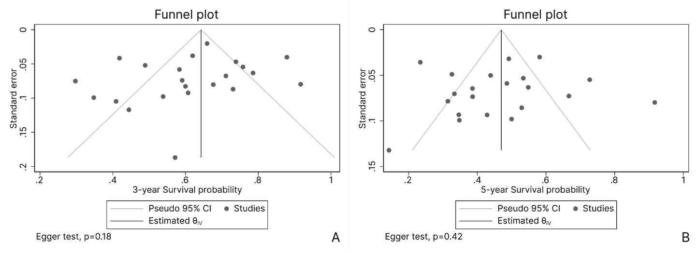Publication bias was assessed by the funnel plots, and the results found that had no significant publication bias and we found that there was not publication bias between the studies for overall 3- and 5-years survival rates (p=0.18 and p=0.42, respectively) (Figures 3A and 3B, respectively).

Figure 3. Funnel plots of publication bias of the 3- and 5-years studies included on the meta-analysis.

Furthermore, recurrence rate assessed in 20 studies was 51% (41 to 60), the included studies have a significant heterogeneity (I²=93.15, p<0.01) (Figure 4A) and there is not publication bias (Egger test, p=0.45) (Figure 4B).

Figure 4. Forest plot and Funnel plot recurrence rate of patients after completing LFA.

Additional analysis was performed according to the approach types of primary (classical), live-first (reverse) and combined were performed to estimate the relationship between 3-and 5-year survival rates and approaches, as well recurrence rate and approaches. There were no statistically differences found between groups regarding 3-years survival rates (p=0.31), 5-year survival rates (p=0.31), and recurrence rate (p=0.09). (Sup 1)

The 3 and 5 years survival an recurrence rates were respectively 70% (45 to 96, 2 studies), 44% (29 to 58, 7 studies) and 65% (53 to 77, 5 studies) for the classical approach; 65% (51 to 79, 2 studies), 61% (44 to 77, 2 studies) and 52 (47 to 57, 2 studies) for combined approach and; 80 (67 to 92, 2 studies), 51% (33 to 69, 5 studies) and 65% (47 to 83, 5 studies) for Reverse approach.

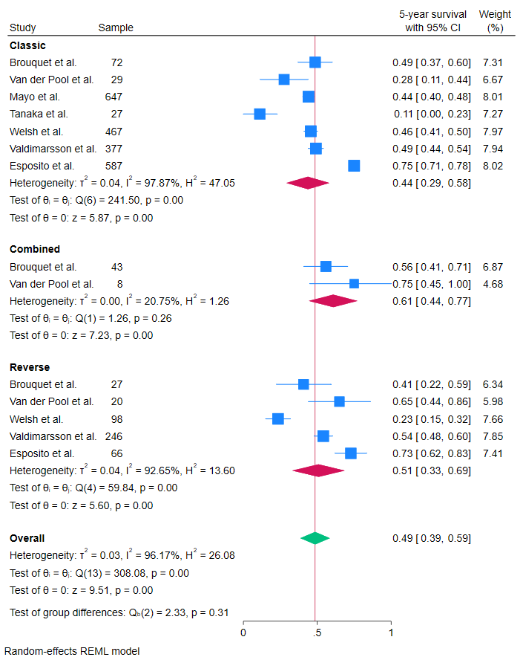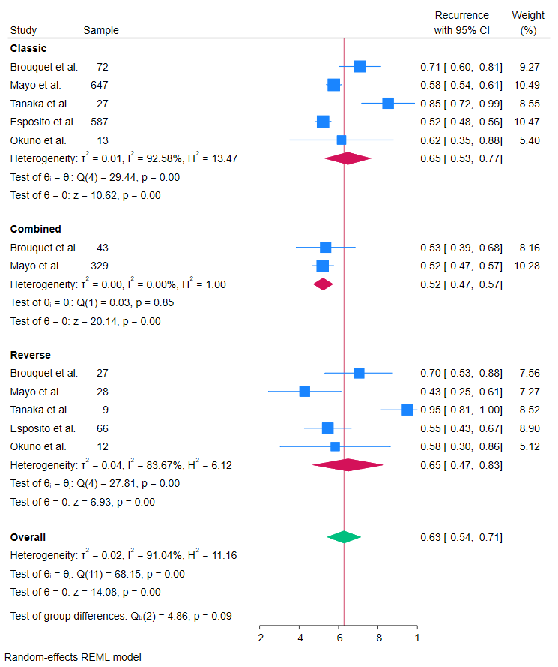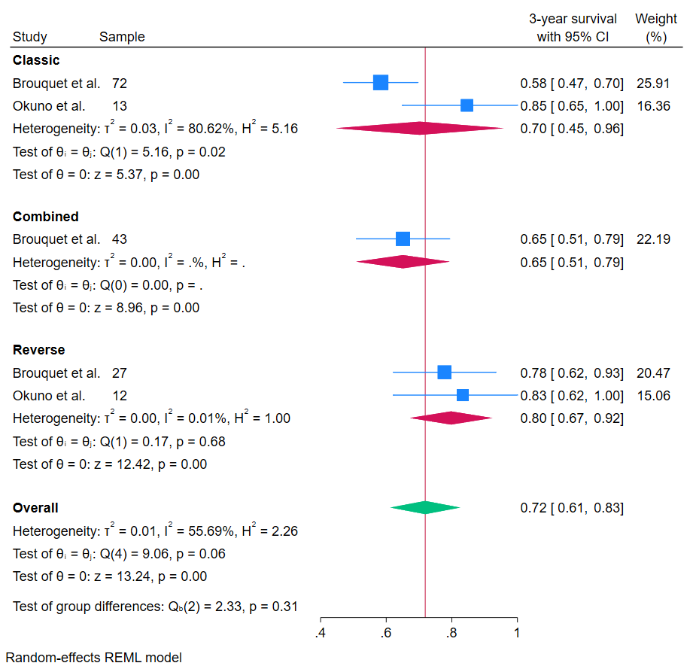

**DISCUSSION**

CRC metastatic liver disease is a major clinical issue. The liver is the main site of metastases in CRC patients and while two-thirds of patients have extrahepatic spread, others have isolated liver disease. Treatments available for CRC liver metastases include surgical resection, thermal removal, regional hepatic intraarterial chemotherapy, chemoembolization, radioembolization and radiation therapy, including stereotactic radiation therapy. Among these treatments, surgical resection remains the gold standard, as it is associated with higher long-term disease-free survival.

The moment and sequence of surgical resection remain controversial (43) but depend mainly on the symptoms and burden of disease: (i) patients who have complications of primary CRC, such as bleeding, obstruction or perforation, should be initially submitted to colorectal tumor resection. The use of LFA can delay the resection of CRC and increase the risk of developing complications related to colorectal tumor, since studies have shown that the rates of bleeding, obstruction, and perforation reach 20% (27,45); (ii) - asymptomatic patients with primary CRC may undergo simultaneous or staged resection depending on the extent of liver involvement; (iv) - patients with CRC in a favorable location (e.g., right colon) and limited hepatic metastases may be submitted to simultaneous resection of CRC and liver metastases; (iv) - patients who are treated with neoadjuvant chemotherapy may benefit from a two-stage hepatic approach: patients with locally advanced rectal cancer (T4 and/or bulky tumor, or extensive lymph node disease) may benefit from the intensification of preoperative therapy using induction chemotherapy followed by chemoradiotherapy instead of isolated chemoradiotherapy (27,45,46). If such patients have synchronous and potentially resectable liver metastases, they may undergo LFA after four months of induction chemotherapy. Then, a new chemotherapy therapy is performed for another two months, and after 4 to 8 weeks of the end of the QT, the colorectal resection can be performed (46).

In patients with synchronous CRC and CLM, preoperative chemotherapy with oxaliplatin and/or irinotecan-based regimens induced an important histological response to CRC (3,4,8,10). This response has been significantly associated with a CLM response and has led to a decrease and conversion of the non-resectable disease to a resectable disease (downstaging) (12,14,16,23).

Liver resection of CLM was contraindicated in patients with more than 4 metastases, presence of extrahepatic disease, or when the free margin of resection was less than 1 cm (3,5,11,13). However, studies have shown that patients with these clinical pathological factors can achieve long-term survival after liver resection and should not be excluded from being candidates for surgical approach (4,5,19).

During this review, a collective analysis was conducted in which the data of all selected articles were grouped as if they resulted from a single sample. It must be recognized that, among the articles in this study, there is a great deal of heterogeneity in their design, and, in addition, different results must be taken into account. Moreover, few studies report this approach and are not representative of the contingent of patients with synchronous CLM. Currently, there is no randomized controlled study comparing different methods of treatment of CLM. There are significant differences in chemotherapy regimens, particularly with respect to new biological agents. The published series showed differences in patient age, CRC site, and liver metastasis characteristics (size, number, and distribution). These variables insert heterogeneity and information, making any potential conclusion impossible.

The lack of uniformity in the definition of irresectability was an important restriction for the critical evaluation of the results of hepatic resection of CLM initially untreatable after neoadjuvant chemotherapy. The standardization of irresectability criteria will certainly facilitate a better understanding of the role of neoadjuvant chemotherapy and will also ensure that the best treatment is offered to all potential resection candidates. It is clear that the widespread adoption of uniform definitions will assist in the interpretation of the results of future studies.

Only two of the selected articles objectively evaluated liver damage caused by chemotherapy, such as fibrosis, steatohepatitis and sinusoidal damage. This may increase the risk of liver failure in these patients, especially following extended hepatic resection.

The successful completion of treatment with LFA depends on obtaining a downstaging in response to neoadjuvant chemotherapy (32-34,37). In this systematic review, the LFA procedure was performed in 80.6% of cases, indicating a high response rate. Reasons for failure of therapy included disease progression, new extrahepatic disease, postoperative death after hepatic resection (30 days) and loss of follow-up (36,38,41).

Most patients underwent extensive liver resections. R0 resection was performed in 936 patients (69.2%) of 1352 patients who completed the protocol (29-47,49-55,57-59). The post-hepatectomy morbidity rate was 30.6%, with a postoperative mortality rate (30 days) of 5.7%. These outcomes indicated that chemotherapy for downstaging did not prevent patients from performing extensive liver resection with a high chance of achieving R0 resection. Total mean OS at 3 and 5 years were 62.9% and 47.4%, respectively.

The present study revealed that LFA in patients with CRC and synchronous CLM has low perioperative morbidity and mortality, as well as satisfactory survival outcomes (29-45,48-59). These results are comparable with the results of studies in patients undergoing the classical approach (resection of the CRC and subsequent resection of the MHCCR) (29,31-33,35,38-40,42,43,48,50-54,56,). In this review, the survival outcomes of retrospective and comparative cohort studies between the classical approach and the LFA can be compared. In these studies, in the classical approach, the mean disease-free survival in months was 28.5 months and overall survival of 1, 3 and 5 years were 99.5%, 76.5% and 50.9%, respectively (29.31-33.35.38-40.42.43) (WINTER).

In order to avoid information and data estimation biases, we chose not to count the secondary results of reports in which there were data discrepancies (31,32,35,38-40,42,43,48).

The results observed in this review support liver resection as the gold standard surgical method, as well as the curative treatment of choice for CLM (34,37,39,40). These data were confirmed following the meta-analysis, including the survival curve for the patients evaluated in the reviewed studies (Winter). In a meta-analysis study, Zeyara et al. (47) evaluated SPS and clinicopathological data of patients undergoing LFA. The study included 17 articles that totaled 1,041 patients. As a result, the authors observed an average LFA completion rate of 80% and a median overall survival for the LFA completion and noncompletion groups of 45 and 13 months, respectively. Furthermore, the metadata showed a significant survival benefit for the group that completed processing with the LFA. The main cause of noncompletion (76%) was the progression of liver disease before resection of the primary colorectal tumor.

The major limitation of this study was that all included articles were retrospective and based on odds ratio measures, which made difficult the hazard ratio analysis, which, despite being less susceptible to bias, behaves in a similar way to the odds ratio.

It should be recognized that the preponderance of the articles in this review encompasses a small number of patients with metastatic tumors initially resectable and that there is substantial heterogeneity in their strategies. Heterogeneity is attributable to differences in interventions, such as the type of surgery and use of ablative techniques, outcome evaluations and number of patients. Furthermore, there was significant heterogeneity in the 5-year overall survival indices for patients treated with LFA.

**CONCLUSIONS**

In patients with a high load of liver tumor, it is critical to control the disease with chemotherapy for the improvement of disease staging and an initial liver resection should be considered for these patients, as this can influence their long-term survival. The LFA can offer the possibility of a complete resection of the CLM and an overall survival benefit when completion can be guaranteed. The risk of non-completion of LFA is related to the higher number of liver metastases. The decision regarding the time of CRC and CLM resections should be personalized for each patient. There is a growing need for randomized controlled and multi-institutional studies as the next step in the study of AHP for CLM.

**REFERENCES**

1. Siegel RL, Deepa Naishadham, Jemal A. Cancer statistics, 2012. 2012 Jan 1 [cited 2023 May 23];62(1):10–29. Available from: https://pubmed.ncbi.nlm.nih.gov/22237781/
2. Araghi M, Soerjomataram I, Jenkins MA, Brierley JD, Morris E, Bray F, et al. Global trends in colorectal cancer mortality: projections to the year 2035. 2019 Jun 15 [cited 2023 May 23];144(12):2992–3000. Available from: <https://pubmed.ncbi.nlm.nih.gov/30536395/>
3. Agneta Norén, Eriksson HG, Olsson LI. Selection for surgery and survival of synchronous colorectal liver metastases; a nationwide study. 2016 Jan 1 [cited 2023 May 23];53:105–14. Available from: https://pubmed.ncbi.nlm.nih.gov/26702764/
4. Silberhumer GR, Paty PB, Denton BT, Guillem JG, Mithat Gonen, Raphael, et al. Long-term oncologic outcomes for simultaneous resection of synchronous metastatic liver and primary colorectal cancer. 2016 Jul 1 [cited 2023 May 23];160(1):67–73. Available from: <https://pubmed.ncbi.nlm.nih.gov/27079362/>
5. Ki Chang Jang, Chan Yun Kim, Kim KH, Lim SB, Chang Sik Yu, Tae Yong Kim, et al. Prognostic Factors in Terms of the Number of Metastatic Nodules in Patients With Colorectal Cancer Liver Metastases. 2016 Jun 1 [cited 2023 May 23];32(3):92–2. Available from: <https://pubmed.ncbi.nlm.nih.gov/27437390/>
6. Eran Sadot, Groot Koerkamp B, J. Sanchez Leal, Shia J, Mithat Gonen, Allen PK, et al. Resection Margin and Survival in 2368 Patients Undergoing Hepatic Resection for Metastatic Colorectal Cancer. 2015 Sep 1 [cited 2023 May 23];262(3):476–85. Available from: <https://pubmed.ncbi.nlm.nih.gov/26258316/>
7. Adam R, Aimery de Gramont, Figueras J, Norihiro Kokudo, Kunstlinger F, Loyer EM, et al. Managing synchronous liver metastases from colorectal cancer: A multidisciplinary international consensus. 2015 Nov 1 [cited 2023 May 23];41(9):729–41. Available from: <https://pubmed.ncbi.nlm.nih.gov/26417845/>
8. Ali M, Stefano Di Sandro, Lauterio A, G. Concone, Iacopo Mangoni, Ferla F, et al. Repeat Hepatectomy for Recurrent Colorectal Liver Metastases: Is it Worth the Challenge? 2015 Sep 11 [cited 2023 May 23];19(12):2192–8. Available from: <https://pubmed.ncbi.nlm.nih.gov/26361773/>
9. Berti S, Francone E, Minuto M, Bonfante P, Sagnelli C, Bianchi C, et al. Synchronous totally laparoscopic management of colorectal cancer and resectable liver metastases: a single center experience. 2015 Feb 14 [cited 2023 May 23];400(4):495–503. Available from: <https://pubmed.ncbi.nlm.nih.gov/25681240/>
10. Hiroaki Niitsu, Takao Hinoi, Shimomura M, Hiroyuki Egi, Hattori M, Ishizaki Y, et al. Up-front systemic chemotherapy is a feasible option compared to primary tumor resection followed by chemotherapy for colorectal cancer with unresectable synchronous metastases. 2015 Apr 24 [cited 2023 May 23];13(1). Available from: <https://pubmed.ncbi.nlm.nih.gov/25908502/>
11. Luca Viganò, Ferrero A, Roberto Lo Tesoriere, Capussotti L. Liver Surgery for Colorectal Metastases: Results after 10 Years of Follow-Up. Long-Term Survivors, Late Recurrences, and Prognostic Role of Morbidity. 2008 May 8 [cited 2023 May 23];15(9):2458–64. Available from: <https://pubmed.ncbi.nlm.nih.gov/18463927/>
12. Bigourdan JM;Faber B;Rayar M;Chirpaz E;Boucher E;Boudjema K. Disease-Free Survival after Simultaneous or Delayed Resection of Synchronous Colorectal Liver Metastasis and Primary Cancer. Hepato-gastroenterology [Internet]. 2014 [cited 2023 May 23];61(132). Available from: <https://pubmed.ncbi.nlm.nih.gov/26158168/>
13. Pawlik TM, Schulick RD, Choti MA. Expanding Criteria for Resectability of Colorectal Liver Metastases. 2008 Jan 1 [cited 2023 May 23];13(1):51–64. Available from: <https://pubmed.ncbi.nlm.nih.gov/18245012/>
14. Glenn Kunnath Bonney, Coldham C, Adam R, Kaiser GM, Barroso E, Capussotti L, et al. Role of neoadjuvant chemotherapy in resectable synchronous colorectal liver metastasis; An international multi-center data analysis using LiverMetSurvey. 2015 May 1 [cited 2023 May 23];111(6):716–24. Available from: <https://pubmed.ncbi.nlm.nih.gov/25864987/>
15. Osada. Surgical Indications for Multiple and Synchronous Liver Metastases from Colorectal Cancer. Hepato-gastroenterology [Internet]. 2014 [cited 2023 May 23];61(131). Available from: <https://pubmed.ncbi.nlm.nih.gov/26176064/>
16. Baba K. Successful treatment of conversion chemotherapy for initially unresectable synchronous colorectal liver metastasis. 2015 Feb 14 [cited 2023 May 23];21(6):1982–2. Available from: <https://pubmed.ncbi.nlm.nih.gov/25684967/>
17. Veereman G, Robays J, Leen Verleye, Leroy R, Rolfo C, Eric Van Cutsem, et al. Pooled analysis of the surgical treatment for colorectal cancer liver metastases. 2015 Apr 1 [cited 2023 May 23];94(1):122–35. Available from: <https://pubmed.ncbi.nlm.nih.gov/25666309/>
18. Ejaz A, Semenov E, Gaya Spolverato, Kim Y, Tanner D, Hundt J, et al. Synchronous primary colorectal and liver metastasis: impact of operative approach on clinical outcomes and hospital charges. 2014 Dec 1 [cited 2023 May 23];16(12):1117–26. Available from: <https://pubmed.ncbi.nlm.nih.gov/24965845/>
19. Lin Q, Ye QH, Zhu D, Wei Y, Ren L, Ye L, et al. Determinants of Long-Term Outcome in Patients Undergoing Simultaneous Resection of Synchronous Colorectal Liver Metastases. 2014 Aug 27 [cited 2023 May 23];9(8):e105747–7. Available from: <https://pubmed.ncbi.nlm.nih.gov/25162714/>
20. Silberhumer GR, Paty PB, Temple LK, Raphael, Denton BT, Mithat Gonen, et al. Simultaneous resection for rectal cancer with synchronous liver metastasis is a safe procedure. 2015 Jun 1 [cited 2023 May 23];209(6):935–42. Available from: <https://pubmed.ncbi.nlm.nih.gov/25601556/>
21. Brouquet A, Nordlinger B. Surgical Strategies to Synchronous Colorectal Liver Metastases. 2012 Jan 1 [cited 2023 May 23]; Available from: <https://pubmed.ncbi.nlm.nih.gov/23207945/>
22. Butte JM, Mithat Gonen, Ding PR, Goodman KA, Allen PJ, Nash GM, et al. Patterns of failure in patients with early onset (synchronous) resectable liver metastases from rectal cancer. 2012 Nov 1 [cited 2023 May 23];118(21):5414–23. Available from: <https://pubmed.ncbi.nlm.nih.gov/22517058/>
23. Fontana R, Herman P, Pugliese V, Marcos Vinicius Perini, Fabricio Ferreira Coelho, Cecconello I. SURGICAL OUTCOMES AND PROGNOSTIC FACTORS IN PATIENTS WITH SYNCHRONOUS COLORECTAL LIVER METASTASES. 2014 Jan 1 [cited 2023 May 23];51(1):4–9. Available from: <https://pubmed.ncbi.nlm.nih.gov/24760056/>
24. Gilles Mentha, Pietro Majno, Andres A, Rubbia-Brandt L, Morel P, Roth A. Neoadjuvant chemotherapy and resection of advanced synchronous liver metastases before treatment of the colorectal primary. 2006 Jul 1 [cited 2023 May 23];93(7):872–8. Available from: <https://pubmed.ncbi.nlm.nih.gov/16671066/>
25. Dimitrios Kardassis. Patients with multiple synchronous colonic cancer hepatic metastases benefit from enrolment in a “liver first” approach protocol. 2014 Jul 27 [cited 2023 May 23];6(7):513–3. Available from: <https://pubmed.ncbi.nlm.nih.gov/25068003/>
26. Straka M, Matej Skrovina, Soumarová R, Kotasek R, Burda L, Vojtek C. Up front hepatectomy for metastatic rectal carcinoma – reversed, liver first approach. Early experience with 15 patients. 2014 Jan 1 [cited 2023 May 23];61(04):447–52. Available from: <https://pubmed.ncbi.nlm.nih.gov/25027742/>
27. Eric Van Cutsem, Cervantes A, Adam R, Sobrero A, J.H.J.M. van Krieken, Aderka D, et al. ESMO consensus guidelines for the management of patients with metastatic colorectal cancer. 2016 Aug 1 [cited 2023 May 23];27(8):1386–422. Available from: <https://pubmed.ncbi.nlm.nih.gov/27380959/>
28. Fong Y, Fortner JG, Sun RL, Brennan MF, Blumgart LH. Clinical Score for Predicting Recurrence After Hepatic Resection for Metastatic Colorectal Cancer. 1999 Sep 1 [cited 2023 May 23];230(3):309–9. Available from: <https://pubmed.ncbi.nlm.nih.gov/10493478/>
29. Esposito F, Lim C, Antonio Sa Cunha, Pessaux P, Navarro F, Azoulay D. Primary Tumor Versus Liver-First Approach for Synchronous Colorectal Liver Metastases: An Association Française de Chirurgie (AFC) Multicenter-Based Study with Propensity Score Analysis. 2018 Jun 14 [cited 2023 May 23];42(12):4046–53. Available from: <https://pubmed.ncbi.nlm.nih.gov/29947991/>
30. Gilles Mentha, Roth A, Sylvain Terraz, Emiliano Giostra, Pascal Gervaz, Andres A, et al. “Liver First” Approach in the Treatment of Colorectal Cancer with Synchronous Liver Metastases. 2008 Jan 1 [cited 2023 May 23];25(6):430–5. Available from: <https://pubmed.ncbi.nlm.nih.gov/19212115/>
31. Brouquet A, Mortenson MM, Jean Nicolas Vauthey, Rodriguez-Bigas MA, Overman MJ, Chang GJ, et al. Surgical Strategies for Synchronous Colorectal Liver Metastases in 156 Consecutive Patients: Classic, Combined or Reverse Strategy? 2010 Jun 1 [cited 2023 May 23];210(6):934–41. Available from: <https://pubmed.ncbi.nlm.nih.gov/20510802/>
32. Anne, Johannes, Lalmahomed ZS, A. M. M. Eggermont, J. N. M. Ijzermans, Verhoef C. Optimizing the outcome of surgery in patients with rectal cancer and synchronous liver metastases. 2010 Mar 1 [cited 2023 May 23];97(3):383–90. Available from: <https://pubmed.ncbi.nlm.nih.gov/20101594/>
33. Jong, Ronald, Maas M, Marc H.A. Bemelmans, W.M S, Beets GL, et al. The liver-first approach for synchronous colorectal liver metastasis: a 5-year single-centre experience. 2011 Oct 1 [cited 2023 May 23];13(10):745–52. Available from: <https://pubmed.ncbi.nlm.nih.gov/21929676/>
34. Ninos Ayez, Jacobus, Anne, Alexander M.M. Eggermont, Grünhagen DJ, Johannes, et al. Long-term Results of the “Liver First” Approach in Patients With Locally Advanced Rectal Cancer and Synchronous Liver Metastases. 2013 Mar 1 [cited 2023 May 23];56(3):281–7. Available from: <https://pubmed.ncbi.nlm.nih.gov/23392140/>
35. Mayo SC, Pulitano C, Marques H, Lamelas J, Wolfgang CL, Wassila De Saussure, et al. Surgical Management of Patients with Synchronous Colorectal Liver Metastasis: A Multicenter International Analysis. 2013 Apr 1 [cited 2023 May 23];216(4):707–16. Available from: <https://pubmed.ncbi.nlm.nih.gov/23433970/>
36. Antonella De Rosa, Gomez D, Hossaini S, Duke K, Fenwick SW, Brooks A, et al. Stage IV colorectal cancer: Outcomes following the liver-first approach. 2013 Dec 1 [cited 2023 May 23];108(7):444–9. Available from: <https://pubmed.ncbi.nlm.nih.gov/24009161/>
37. Buchs NC, Ris F, Pietro Majno, Andres A, Wulfran Cacheux, Pascal Gervaz, et al. Rectal Outcomes After a Liver-First Treatment of Patients with Stage IV Rectal Cancer. 2015 Mar 1 [cited 2023 May 23];22(3):931–7. Available from: <https://pubmed.ncbi.nlm.nih.gov/25201505/>
38. Sabbagh C, J.-M. Regimbeau, T. Ravololoniaina, Chauffert B, Joly JP, Mauvais F, et al. Oncological strategies for middle and low rectal cancer with synchronous liver metastases. 2015 Nov 1 [cited 2023 May 23];23:186–93. Available from: <https://pubmed.ncbi.nlm.nih.gov/26316155/>
39. Tanaka K, Murakami T, Matsuo K, Yukihiko Hiroshima, Endo I, Ichikawa Y, et al. Preliminary Results of “Liver-First” Reverse Management for Advanced and Aggressive Synchronous Colorectal Liver Metastases: A Propensity-Matched Analysis. 2015 Jan 1 [cited 2023 May 23];32(1):16–22. Available from: <https://pubmed.ncbi.nlm.nih.gov/25613745/>
40. Okuno M, Hatano E, Kasai Y, Nishio T, Seo S, Taura K, et al. Feasibility of the liver-first approach for patients with initially unresectable and not optimally resectable synchronous colorectal liver metastases. 2016 Jun 1 [cited 2023 May 23];46(6):721–8. Available from: <https://pubmed.ncbi.nlm.nih.gov/26315324/>
41. Wang K, Liu W, Yan XL, Xing B. Role of a liver-first approach for synchronous colorectal liver metastases. 2016 Feb 14 [cited 2023 May 23];22(6):2126–6. Available from: <https://pubmed.ncbi.nlm.nih.gov/26877617/>
42. Fenella K.S. Welsh, Kandiah Chandrakumaran, John TG, Adrian Ben Cresswell, Rees MJ. Propensity score-matched outcomes analysis of the liver-first approach for synchronous colorectal liver metastases. 2016 Apr 1 [cited 2023 May 23];103(5):600–6. Available from: <https://pubmed.ncbi.nlm.nih.gov/26864820/>
43. Valdimarsson VT, Ingvar Syk, Lindell G, Agneta Norén, Isaksson B, Per Sandström, et al. Outcomes of liver-first strategy and classical strategy for synchronous colorectal liver metastases in Sweden. 2019 Jan 1 [cited 2023 May 23];20(5):441–7. Available from: <https://pubmed.ncbi.nlm.nih.gov/29242035/>
44. Pieter M. H. Nierop, Verseveld M, Benno Galjart, Joost Rothbarth, Nuyttens JJ, E. van Meerten, et al. The liver-first approach for locally advanced rectal cancer and synchronous liver metastases. 2019 Apr 1 [cited 2023 May 23];45(4):591–6. Available from: <https://pubmed.ncbi.nlm.nih.gov/30554788/>
45. Jong, Rianne C.J. Beckers, Victor van Woerden, Sijmons J, Marc H.A. Bemelmans, Ronald, et al. The liver-first approach for synchronous colorectal liver metastases: more than a decade of experience in a single centre. 2018 Feb 15 [cited 2023 May 23];20(7):631–40. Available from: <https://pubmed.ncbi.nlm.nih.gov/29456199/>
46. Siriwardena AK, Mason J, Saifee Mullamitha, Hancock HC, Santhalingam Jegatheeswaran. Management of colorectal cancer presenting with synchronous liver metastases. 2014 Aug 1 [cited 2023 May 23];11(8):446–59. Available from: <https://pubmed.ncbi.nlm.nih.gov/24889770/>
47. Zeyara A, Torén W, Kjetil Søreide, Andersson R. The liver-first approach for synchronous colorectal liver metastases: A systematic review and meta-analysis of completion rates and effects on survival. 2021 Oct 3 [cited 2023 May 23];111(1):145749692110301-145749692110301. Available from: <https://pubmed.ncbi.nlm.nih.gov/34605325/>
48. Giuliante, Felice, et al. "Liver-first approach for synchronous colorectal metastases: analysis of 7360 patients from the livermetsurvey registry." *Annals of surgical oncology* 28 (2021): 8198-8208.
49. Fonollosa, Eric Herrero, et al. "Long-term results of liver-first approach strategy in patients with advanced synchronous liver metastases from colorectal cancer." *Cirugía Española (English Edition)* 101.5 (2023): 341-349.
50. Carbone, Fabio, et al. "Which surgical strategy for colorectal cancer with synchronous hepatic metastases provides the best outcome? A comparison between primary first, liver first and simultaneous approach." *Updates in Surgery* 74.2 (2022): 451-465.
51. Frühling, Petter, et al. "A comparison of the simultaneous, liver-first, and colorectal-first strategies for surgical treatment of synchronous colorectal liver metastases at two major liver-surgery institutions in Sweden." *Hpb* 25.1 (2023): 26-36.
52. Raoux, L., et al. "Impact of the strategy for curative treatment of synchronous colorectal cancer liver metastases." *Journal of Visceral Surgery* 157.4 (2020): 289-299.
53. Reding, D., Pestalozzi, B. C., Breitenstein, S., Stupp, R., Clavien, P. A., Slankamenac, K., & Samaras, P. (2017). Treatment strategies and outcome of surgery for synchronous colorectal liver metastases. *Swiss medical weekly*, *147*, w14486.
54. Maki, H., Ayabe, R. I., Nishioka, Y., Konishi, T., Newhook, T. E., Tran Cao, H. S., ... & Vauthey, J. N. (2023). Hepatectomy before primary tumor resection as preferred approach for synchronous liver metastases from rectal cancer. *Annals of surgical oncology*, 1-11.
55. Berardi, G., De Man, M., Laurent, S., Smeets, P., Tomassini, F., Ariotti, R., ... & Troisi, R. I. (2018). Radiologic and pathologic response to neoadjuvant chemotherapy predicts survival in patients undergoing the liver-first approach for synchronous colorectal liver metastases. *European Journal of Surgical Oncology*, *44*(7), 1069-1077.
56. Vallance, A. E., Van der Meulen, J., Kuryba, A., Charman, S. C., Botterill, I. D., Prasad, K. R., ... & Walker, K. (2018). The timing of liver resection in patients with colorectal cancer and synchronous liver metastases: a population‐based study of current practice and survival. *Colorectal Disease*, *20*(6), 486-495.
57. Ramia, J. M., Villodre-Tudela, C., Falgueras-Verdaguer, L., Zambudio-Carroll, N., Castell-Gómez, J. T., Carbonell-Morote, S., ... & Serradilla-Martín, M. (2024). Textbook outcomes in the liver-first approach for colorectal liver metastases: prospective multicentre analysis. *BJS open*, *8*(1), zrad123.
58. Labori, K. J., Guren, M. G., Brudvik, K. W., Røsok, B. I., Waage, A., Nesbakken, A., ... & Bjørnbeth, B. A. (2017). Resection of synchronous liver metastases between radiotherapy and definitive surgery for locally advanced rectal cancer: short‐term surgical outcomes, overall survival and recurrence‐free survival. *Colorectal Disease*, *19*(8), 731-738.
59. Du Pasquier, C., Roulin, D., Bize, P., Sempoux, C., Rebecchini, C., Montemurro, M., ... & Demartines, N. (2020). Tumor response and outcome after reverse treatment for patients with synchronous colorectal liver metastasis: a cohort study. *BMC surgery*, *20*(1), 1-8.